FEEL GOOD FRIDAY CHALLENGES |  | Brain Booster:  Let’s look after your mental health… | Curious Challenge:  Let’s be curious and explore outdoors…
Week 1 | 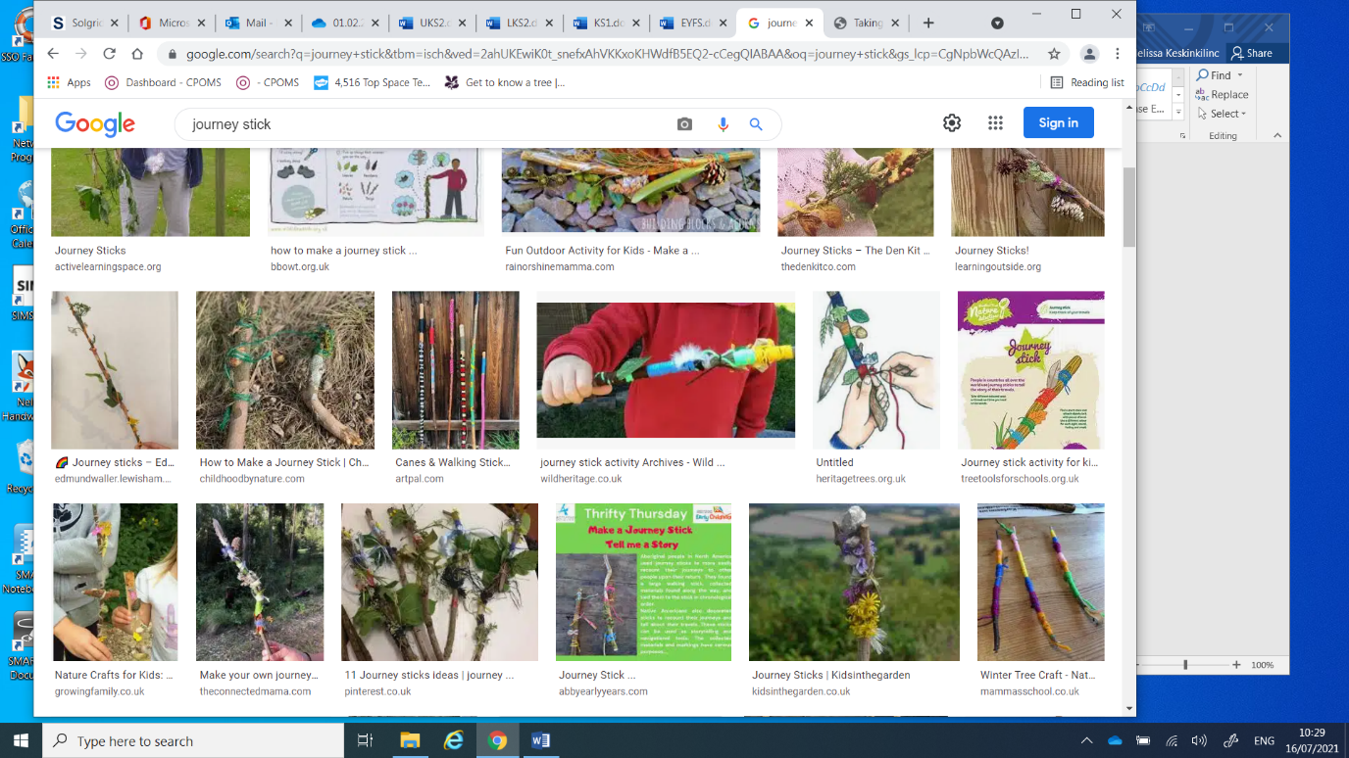 | Using our imagination  Let’s use our imagination to understand how what happens in our minds is connected to what happens in our bodies. ​ Imagine you have a lemon in your hand. You cut it in half and then take a big bite out of it.​ Did anything happen in your mouth?​ Did your body react as if you had really taken a bite out of the sour lemon?​ Can you think of any other times when your body has reacted as if something has really happened, when really it was just a thought?​ | Notice the changes around you  What changes are going on around you outside? Go on a walk outside and document your journey. Find a stick and bring some string to create a journey stick. As you go on your walk see what you can find around you to add to your journey stick. This might be leaves that have fallen from trees, bark rubbings or even photographs that you add after your walk!
 | 7 is the answer. What is the question?
Week 2 | 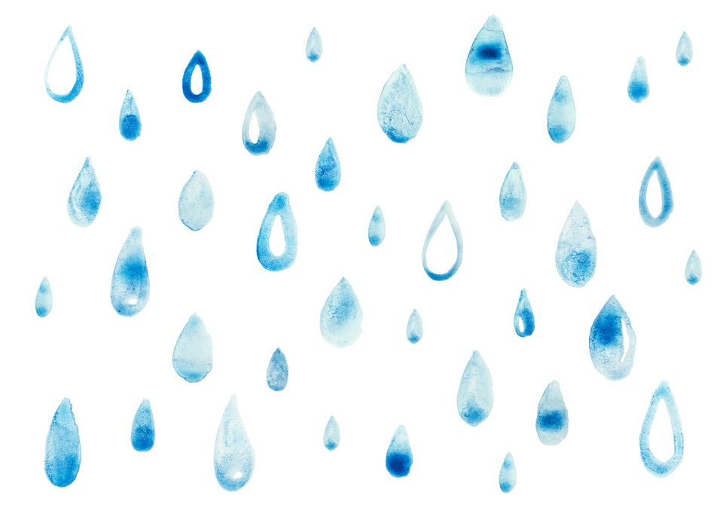 | Thinking time  Close your eyes and sit up straight, feeling relaxed. Pay attention to the thoughts in your mind. Are they busy, busy, busy? ​ Imagine your thoughts as dust clinging to your skin. ​Now imagine going outside and it’s just started to rain. The rain washes off the dust and your thoughts drain away. ​ Imagine the sun has come out and it dries your skin and clothes. ​Pay attention to the thoughts in your mind. Are they quieter? | Exploring Ice  In countries that are colder than ours they have lots of ice and snow, and they sometime use this material to create places to shelter. Do a little research about ice hotels! Can you create your own ice hotel using ice? How can you use this to build with? What happens when you touch the ice? Document your progress with photos so you can look back at it after it has melted!
 | September is the answer. What is the question?
Week 3 | 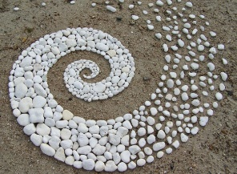 | Let’s be thankful  Take time every day to feel thankful for someone or something you love or something wonderful that happened to you. ​Notice your breathing – take 3 slow, mindful breaths and feel thankful. Share with your friends what you are thankful for or write or draw about it. | Creating Artwork with Nature  Have you heard of the artist Andy Goldsworthy? If not, then look him up and see what he creates! He uses natural resources to create large natural artwork. See if you can create a piece of natural artwork using the resources you can find!
 | What are the advantages and disadvantages of having a chair made out of chocolate?
Week 4 | 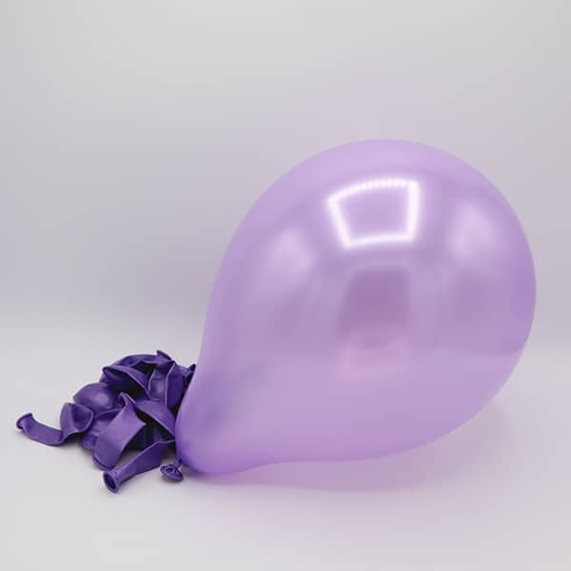 | ​Balloon Breathing  Sit or stand up nice and straight​. Place your hand on your belly​. Breathe in making your belly bigger just like a balloon inflating​. Breathe out making your belly smaller just like a balloon deflating. Count as you breathe. Breathe in - two - three​. Breathe out - two - three​ | Plant bulbs and seeds.  Have you planted any seeds or bulbs? Do you know what bulbs are and how they grow? If not then do a little research to explore what you could plant now that will grow. A great bulb to plant would be daffodils, which will flower in the spring!
 | How would you describe a cat to an alien?
Week 5 | 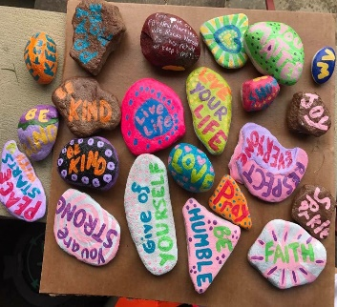 | What makes you special?  Think about the things that make you unique and special. Write your name and decorate it with all the things that make you special. Put this artwork up somewhere that you can see it and share this with your class or family! | Valley Rocks!  Find yourself a rock or stone. Can you paint, draw or decorate your rock? Maybe with something that you enjoy doing or think that you are good at! Or even a positive message for someone who passes by. Make sure it has your name and year group on so it can be added to our Valley Rocks rockery.
 | If you were given five wishes, what would you wish for?
Week 6 | 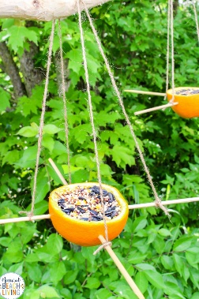 | Expressing our feelings  Take a moment to assess how you are feeling. Choose colours you associate with those feelings, next draw freely on a piece of paper using these colours. Then give your piece of art a title. | Create a bird feeder  The weather is getting colder and birds might find it a little trickier finding food, so let’s give them a little help! You can create your own bird feeder by threading cheerio’s onto string or even using fruit or seeds. There are lots of examples online so find one that you like and give it a go! Maybe you could write or draw instructions for a friend and share these with your class?
 | What animal represents you the best?

